May is the month of Daphne du Maurier

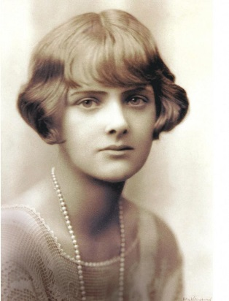
He went down alone to the farm. He saw the car standing by the gate, not in the garage. The windows of the farmhouse were broken. There were dead gulls lying around the house. The living birds sat, quite still, on the trees behind the farm and on the roof of the house.
(The Birds)
  - Daphne du Maurier was born on 13 May 1907 in England. Although she was called as a romantic novelist, her novels and stories rarely had a happy ending. The truth is that many of her stories have a “dark” or paranormal mood. Her bestselling works are The Birds, Rebecca, Jamaica Inn and Don`t look now.
The Birds is a novellete whose plot is set in Cornwall. It`s the story of a farmer, his family and community that are attacked by flocks of seagulls in some kamikaze missions.
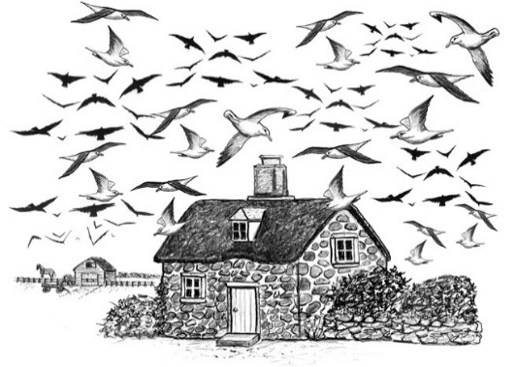
He looked around him. Dead birds lay on the floor. Nan looked down, shocked at the little bodies. There were about fifty of them lying on the floor. They had destroyed themselves against the bedroom walls, or had been destroyed by him in the fight.
(The Birds)
The story was an inspiration for Alfred Hitchcock`s film The Birds, which was released in 1963.

Rebecca is Maurier`s best known work. It has never gone out of print. The novel is known for the character of Mrs. Danvers, the sinister housekeeper, who stays loyal to Rebecca de Winter long after her death.
New Mrs. De Winter has hard times at Manderley (their mansion). Mrs. Danvers “ruins“ the second Mrs. de Winter psychically, saying that she will never be as beautiful, charming and loved as the first Mrs. de Winter. Soon, the second Mrs. de Winter starts to believe that Maxim regrets marrying her and still loves his first wife....

