Put 2 and 2 together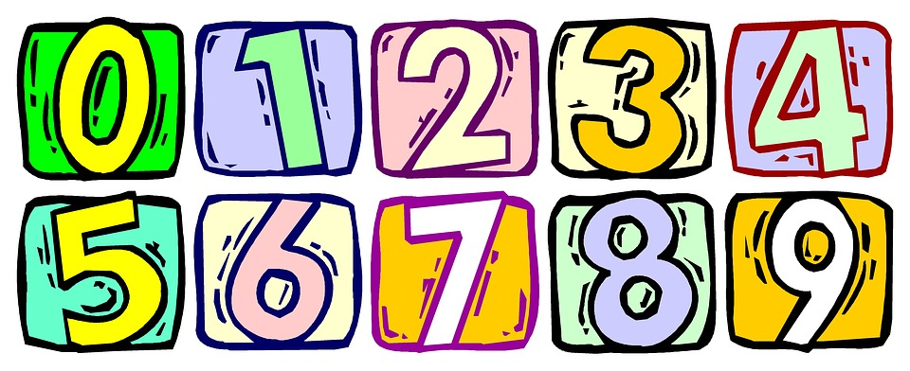

Honestly, I rarely think of numbers as a part of a language. Well, one of the first things we learn is to count: from 1 to 10, later from 10 to 20, from 20 to 100 and so on. Also, when I started with English, counting and naming the numbers in English was an “early must-learn.” And now, many years after, I have to learn again-but this time, I`m going to learn how to use numbers in their idiomatic meaning (prenesený význam).

Let`s start with 1.
“We had one or two ideas about our holiday plans.” → It means we had a few (zopár) ideas, not only one or two.
“They went through the points one by one.“ → They studied the first point, then the second point, then the next, then the next, etc.
2
“I didn`t tell her that Josh had gone away, but she didn`t see his car and put two and two together.” → She understood the situation from what she could see, from information she had.
“I was having second thoughts about moving to Berlin.”→ When people have second thoughts, they doubt their decisions, they are about to change their opinions.
10
“Ten to one they`ll come late again.”→ very probably
50
“Let`s go fifty-fifty on dinner at Ginno`s.”→ When people go fifty-fifty, they share the cost of something, nobody pays more or less.
“We had a fifty-fifty chance of winning the race.” → Our chance to win was equally likely or unlikely.
100
“Where is Costa Brava located?” “Somewhere near Spain, but I`m not a hundred per cent sure.” → It means I`m not completely sure.
“Every player gave a hundred per cent.”→ Players did their best, they tried as hard as they could.

1m
“Do you think Jenny will go on a date with Berry?” “Never in a million years!“ → not at any point, it seems impossible.
When describing people, we often try to guess their age. And, we try to be exact. It`s not necessary, we can talk about somebody`s age in a more gallant way. Look at the following examples:
- He`s in his twenties – between 20 and 29
- He`s in his early twenties – between 21 and 23
- He`s in his mid twenties – between 24 and 26
- He`s in his late twenties- between 27 and 29
You can use it with any age:
Jennifer Lawrence (26): “Jennifer is in her mid twenties.”

Kevin Costner (62): “Kevin is in his early sixties.”

Justin Timberlake (36): “Justin is in his mid thirties.”

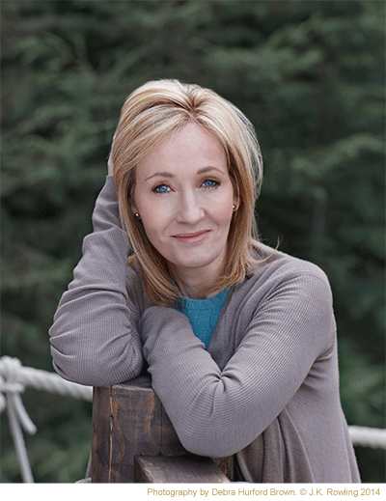
J.K. Rowling (51): “She is in her early fifties.”

